Anik Mridha
Southern New Hampshire University
CYB 210 - Computer Networking
Robert Chubbuck

6-2 Project One
Explanation of Network Segregation
For this project, network traffic was segmented using Virtual Local Area Networks (VLANs) to ensure proper isolation of data, guest, and video traffic. VLANs function by logically dividing a physical network switch into separate broadcast domains, preventing devices in one VLAN from directly communicating with devices in another unless explicitly allowed through routing. This approach enhances both security and performance by minimizing unnecessary broadcast traffic and ensuring sensitive internal devices remain isolated from guest devices or unmanaged equipment.
To meet the project requirements, two new VLANs were created: VLAN 70 (Guest) and VLAN 80 (Video). The existing network already utilized VLAN 50 (Data) for office workstation traffic and VLAN 150 (Voice) reserved for future voice-over-IP expansion. Guest devices were assigned to VLAN 70, ensuring that customer devices connecting to the open wireless network remained completely separated from internal resources. Likewise, the two security cameras installed at the front desk and waiting area were assigned to VLAN 80, creating a dedicated segment for video traffic. This prevents guest users and internal data users from accessing or interfering with the camera system.
Segmentation was validated through a series of ping tests. Devices within the same VLAN were able to communicate successfully—for example, the smartphone on the guest wireless network could ping another guest device and the wireless router providing DHCP services. However, when attempting to ping devices assigned to VLAN 80 (such as the cameras), the ping requests failed, indicating that inter-VLAN traffic was properly restricted. This behavior confirms effective isolation: guest traffic is contained within VLAN 70, video camera traffic is contained within VLAN 80, and internal office traffic remains within VLAN 50. By implementing VLAN-based segmentation, the network meets both the functional and security requirements of the scenario, reducing risk by ensuring that unmanaged guest devices cannot communicate with internal or video infrastructure.
Scalability Planning for the Guest Wireless Network
When configuring the guest wireless network, scalability and efficient IP address management were key considerations. The project scenario required providing free guest Wi-Fi access for up to 70 customers, each potentially connected for up to four hours. To meet this requirement, the wireless router was configured with a DHCP pool beginning at 192.168.70.100, using a private Class C subnet suited for small to medium guest environments. Setting the DHCP pool to accommodate exactly 70 potential devices ensures address availability without over-allocating unnecessary IP space. The address range from 192.168.70.100 through 192.168.70.169 provides 70 total IP addresses, satisfying the expected guest capacity while keeping the scope focused and manageable.
The design also supports future scalability. If guest usage increases, the DHCP pool can be easily expanded by adjusting the starting or ending address, or by modifying the subnet mask. Additionally, the decision to keep the network open and unsecured aligns with the scenario’s requirement for ease of access but also reinforces the importance of strict VLAN segmentation to protect internal assets. Since this router is isolated in VLAN 70, even an increase in the number of guest users will not impact performance or security on other segments of the network.
DHCP lease duration was another factor considered for scalability. Shorter lease times are generally useful in high-turnover environments like waiting areas, as they allow the DHCP server to reclaim unused IP addresses more quickly. While the scenario did not specify an exact lease duration, configuring a realistic and efficient lease time helps ensure that IP addresses are recycled appropriately, even during periods of higher traffic. Overall, planning the addressing scheme and DHCP configuration with expected usage patterns in mind ensures the guest wireless network can meet current needs while remaining flexible for future growth.
Conclusion
The reconfigured network successfully meets the project requirements through effective VLAN-based segmentation and careful planning of the guest wireless network’s IP addressing. By logically isolating guest, video, and internal data traffic, the network enhances security and minimizes unnecessary cross-communication between devices. The DHCP configuration for the guest network ensures adequate support for up to 70 simultaneous users while maintaining the flexibility needed for future expansion. Together, these design decisions demonstrate a scalable, secure, and well-organized network suitable for the evolving needs of the organization.

Project Screenshot

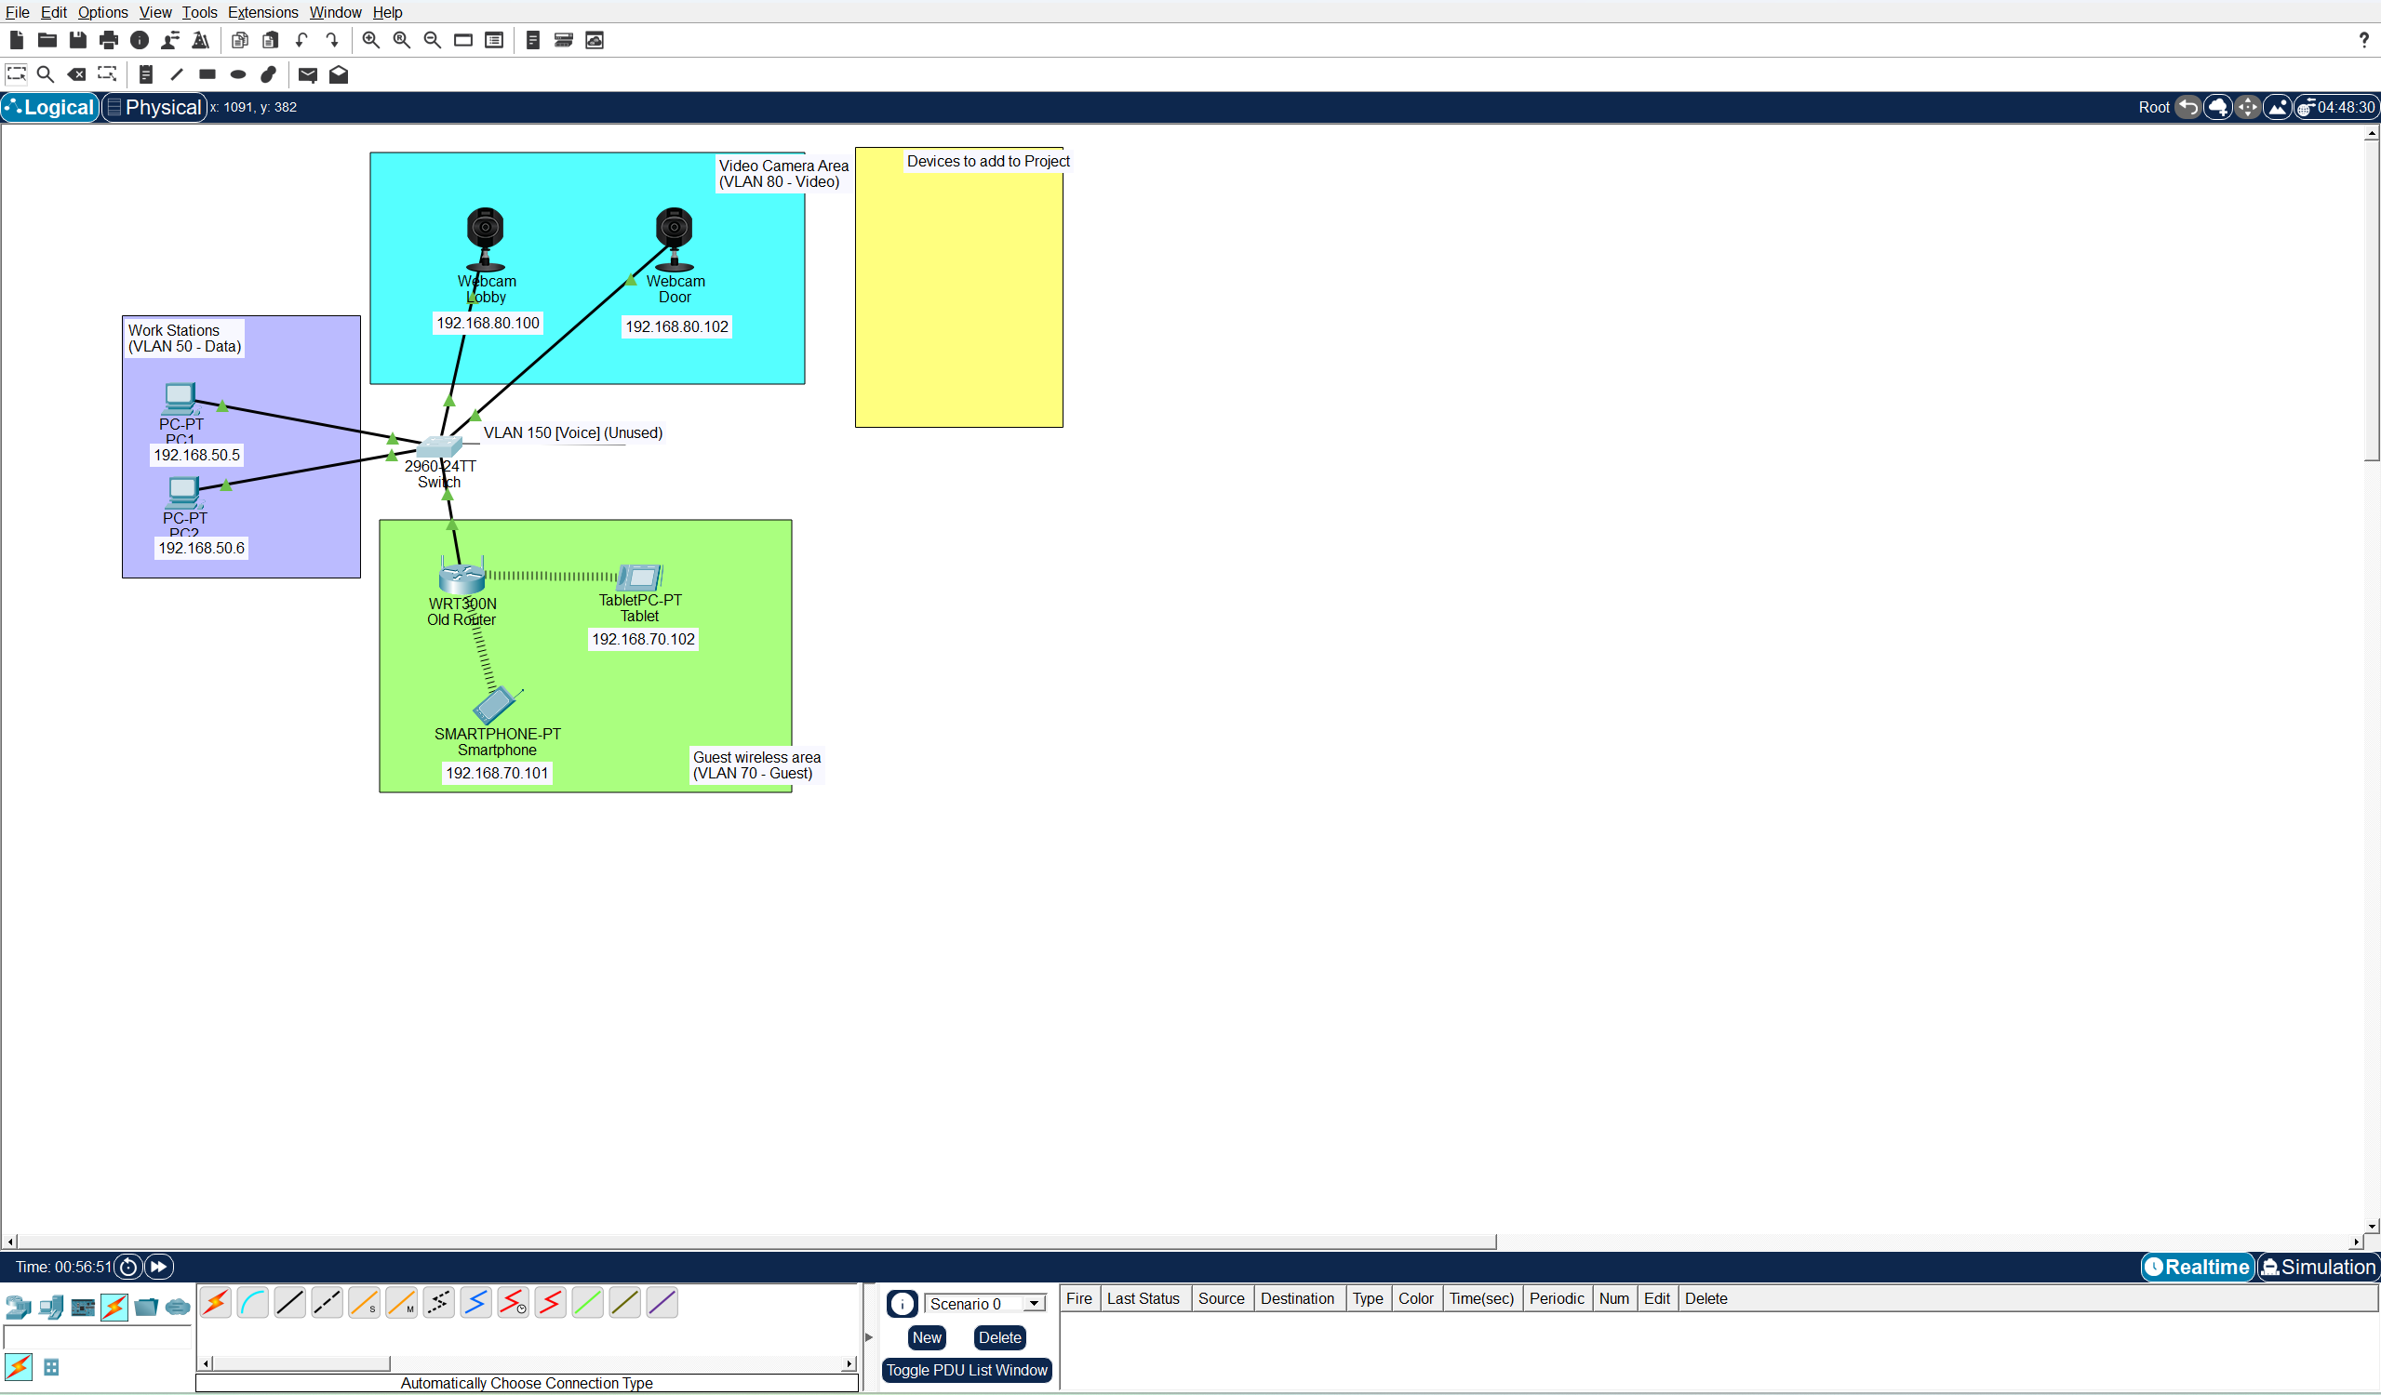
Topology of reconfigured network diagram. Corresponding IP addresses have been labeled to connected devices and cameras to their associated segmented networks.
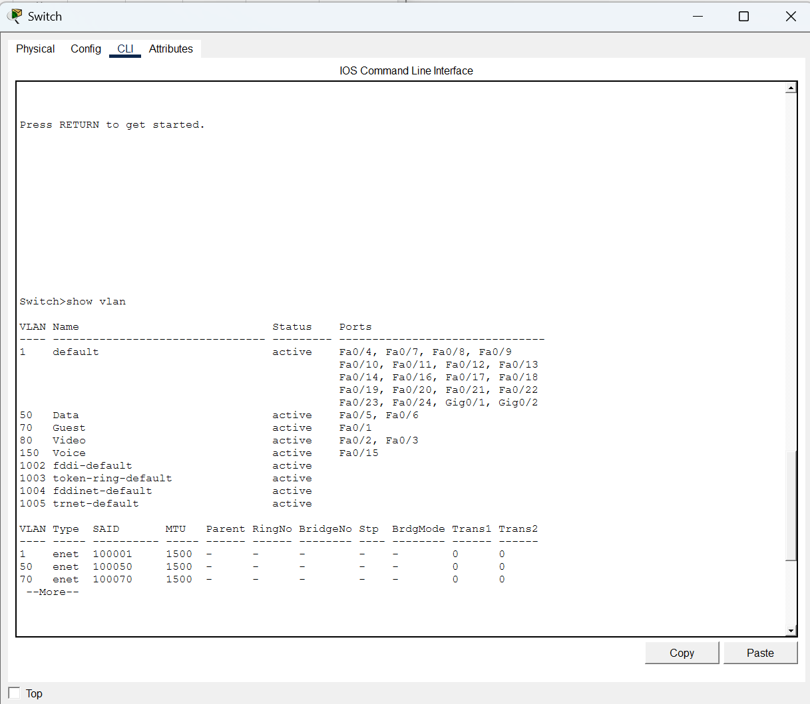
Switch CLI showcasing the VLAN table for the network. 2 VLANS were created for the reconfigured network, VLAN 70 (guest) and VLAN 80 (Video). They were created for the purpose of segmenting the network for guest devices and cameras.
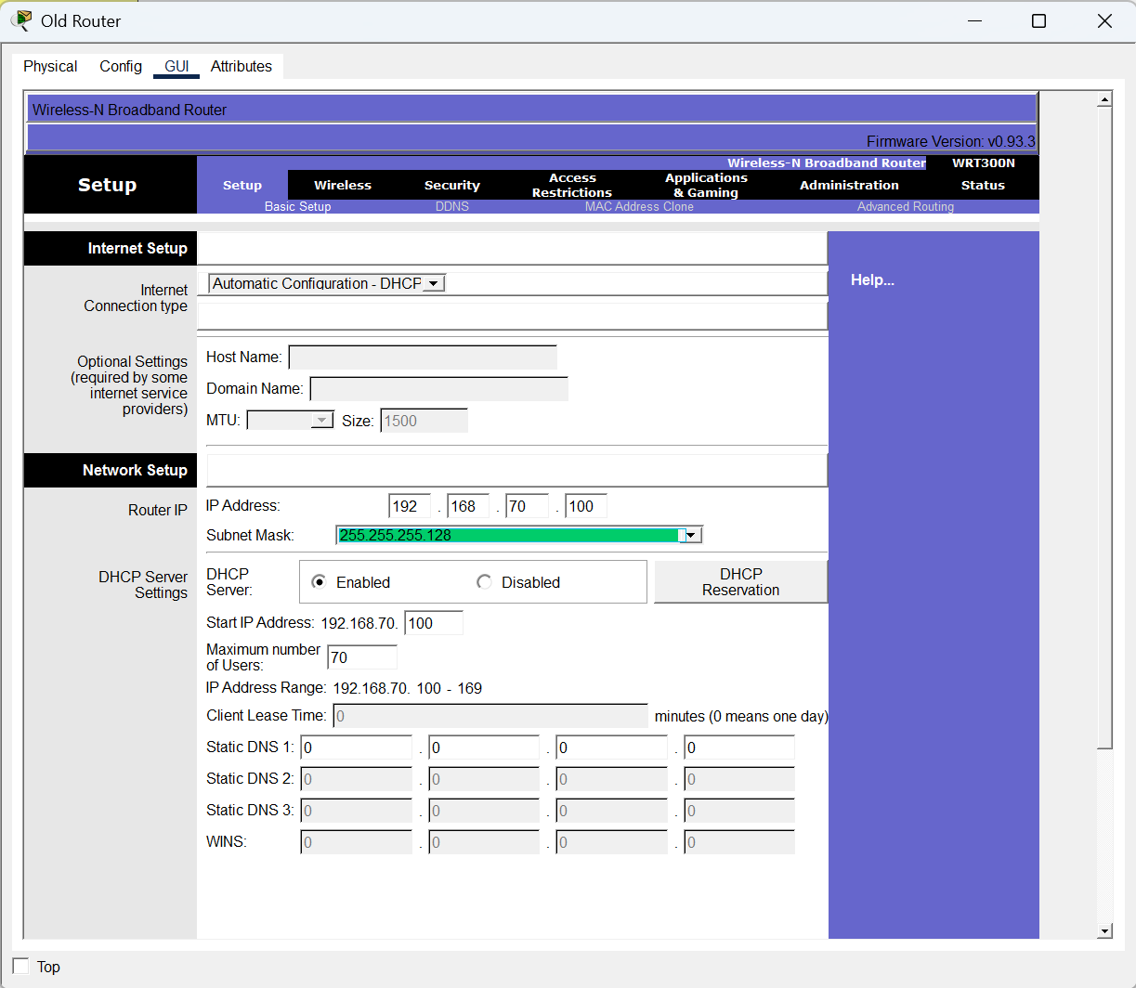
Wireless settings for the wireless router. The router has been configured so that the starting IP is 192.168.70.100 per project specifications. Since we are assuming no more than 70 guests will be on the network, the maximum number of users has been set to 70. This gives us an IP address range of 192.168.70.100 – 169. This configuration addresses scalability of the guest network to meet project requirements.
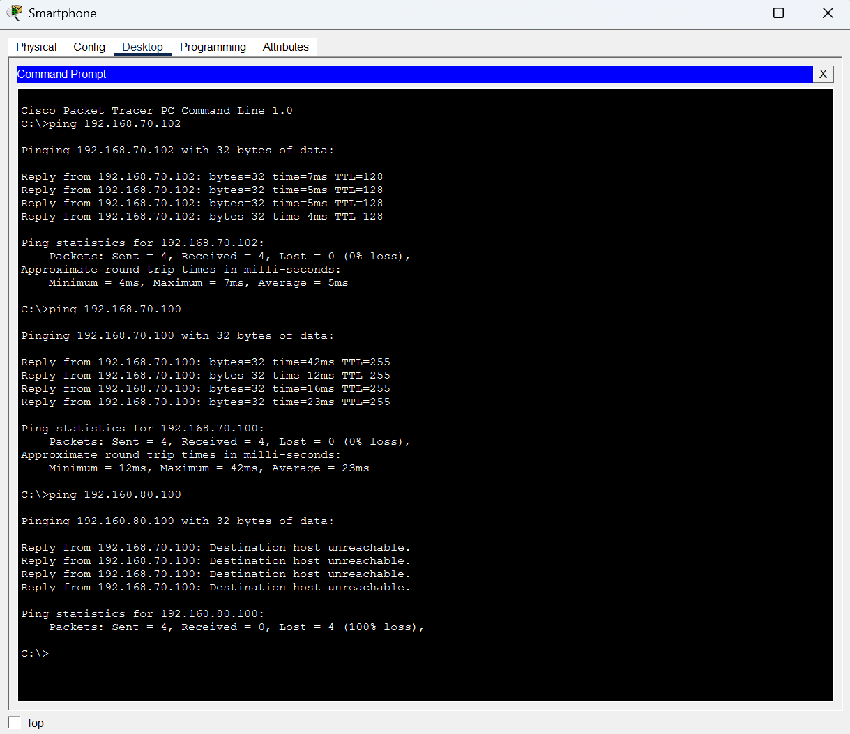
Ping test from Smartphone to another guest device, the old router, and video camera in a different segmented area. The smartphone had successful tests from pinging the guest device and old router, which falls in line with the project as both devices are in the same VLAN. With attempting to ping the cameras, the test failed. This demonstrates the segmentation of the network.

